Building
A
Bicycle Friendly
Village

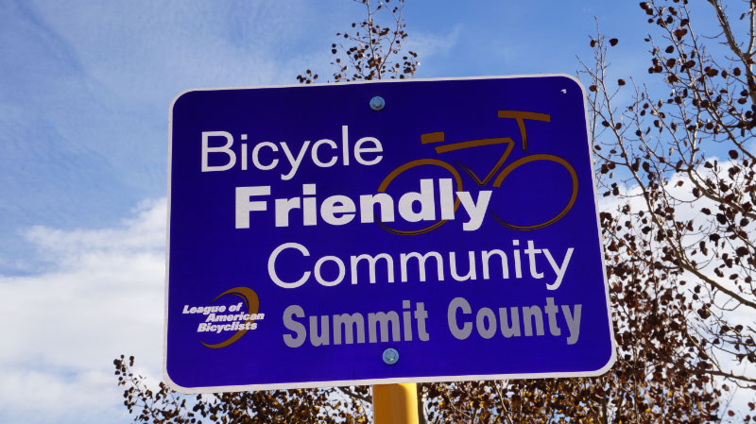

PURPOSE: To provide a framework that will quickly allow Hot Springs Village to be recognized as a Bicycle Friendly Village by its residents, visitors and would-be property owners.

BACKGROUND: Across the U.S., the interest in bicycling is skyrocketing – and it’s easy to see why. A bike is a ticket to health, mobility, freedom and fun. Bicycling isn’t just a way to get from one place to another; it’s an avenue to a better life. And when communities get on board, great things happen.

States, cities and towns across America are investing significant sums of money to provide innovative and improved infrastructure to take advantage of a rapidly growing interest in cycling.

You don’t have to look any farther than Little Rock, where an entire downtown area has been radically transformed through the addition of bike lanes, paved cycle paths and connecting bridges, allowing for over 100 miles of contiguous cycling.

As one who has personally experienced the “before and after” transformation of Little Rock, and seen the benefits of this wholesale metamorphosis, I have to say the City Planners definitely hit the mark. Commerce has literally sprung up out of nowhere to accommodate the large number of cyclists that come in droves to experience the beauty of this master-planned cycling playground.

And Little Rock is in good company. It seems that almost every growing city and master-planned township has cycling in their cross-hairs. A recent visit to The Villages of Florida clearly demonstrates that this growing community “gets it” when it comes to attracting cyclists. Bike lanes and bike-specific signage permeate the entire community. A casual visitor would immediately be alerted that this community catered to cyclists. By doing so, and taking a “build it and they will come” attitude, The Villages now has an active bicycle community with over 1,000 cyclists enjoying structured group rides almost every day of the week. Bicyclists are everywhere!

Hot Springs Village Current Status:

Cyclists are a perceptive crowd. They can immediately sense whether a community is friendly to cyclists. First off, they will notice “bike lanes” – lots of them. They know right off the bat if the community planners place a priority on the safety of cyclists, and painted bike lanes demonstrate this commitment. Secondly, a cyclist will notice signage, such as “Bicycle Friendly Community” and “Yield to Bikes”, or kiosks with signs indicating Bike Maps and Bike Trails. These are all indications that cyclists are welcome in a community.

It is noteworthy that the sport of cycling has (3) types of cyclists:

- Road cyclists – primarily those that ride narrow, high pressure tires on paved roads. Average speed is usually 12-25 miles per hour depending on terrain.
- Mountain Bike cyclists – more rugged-built bikes with wider tires to accommodate dirt, gravel and more off-road terrain.
- Hybrid cyclists – much more casual rider typically owning a heavier, more up-right handlebar type bike. This type of bike could be used on or off road but is less specialized and rides at slower speeds.

With over 450 miles of paved roads in Hot Springs Village, our community has the opportunity to become a mecca for road cyclists. Many of our roads have challenging inclines, nonetheless, there are ample flatter and more gently sloping roads to make this low-traffic community a huge attraction for would-be cyclists. And for those who would say that cycling is in some way un-safe on our Village roads due to automobile traffic, suffice it to say that HSV is FAR safer than any city that most cyclists have been used to. Everything is relative of course, but Hot Springs Village, with its very low traffic count, makes for a stark contrast from the tens of thousands of cars that typical road cyclists compete with on a routine basis.

Further, with almost 30 miles of gravel or semi-paved nature trails, the Village represents a hidden treasure for mountain and hybrid bike riders. The Dam-to-Dam ride from Balboa Beach to the DeSoto Dam levee is almost 26 miles round trip. Any avid mountain bike enthusiast would be excited with the natural scenery experienced along this already constructed path. I know first-hand, as I ride it routinely.

Having been an avid cyclist and racer (both road and mountain) for 25 years, I was disappointed to leave a vibrant cycling community in Plano, Texas seven years ago. And while our family of four has found ways to make cycling “work”, Hot Springs Village is nowhere close to a “cycling destination.” The encouraging news is that HSV has the potential to re-invent itself as a Bicycle Friendly Village and in doing so, will immediately begin to attract a new type of Villager. This Villager has a bike rack on their car, enjoys being in nature, loves to ride in packs with other cyclists, and is “rabid” in telling all their other cycling friends that they have found a community that caters to cycling.

In order to effectively compete with similar communities, Hot Springs Village has no choice but to “GO BIG” in attracting boomer cyclists. They have way too many options and if they don’t find it here, we will never hear from them again.

Making HSV A Bike Friendly Community:

The following is based on input from the Hot Springs Village Cycling Club and is an attempt to make recommendations that will optimize every dollar spent for the greatest gain. It is well understood that every dollar in this campaign must be maximized. Consequently, this Plan incorporates a Phase I and a Phase II approach. Once complete, there will be a much better understanding community-wide of the benefits of this investment.

Phase I

- At both East and West entrances to the Village there needs to be large dedicated signage clearly announcing that Hot Springs Village is friendly to cyclists. Recommended wording would be similar to: “Bicycle Friendly Village” subtitle: “a cyclist paradise”.
- Painted bike lanes should run the entire length of DeSoto. Doing so will alert all cars that bikes are welcome here and they need to be watchful for cyclists. It becomes a dual message of sorts welcoming cyclists and subliminally letting motorists know that they will encounter bikes. If a visitor simply travels DeSoto, they will get a very clear message that cycling is a priority in our Village.
- Painted bike lanes on Ponce Deleon Drive, Balearic and Minorca. These are the main connecting streets for road cycle traffic. They also will serve as connections for cyclists wanting to connect to our (3) major off-road trail systems (Hernando, Cedar Creek, DeSoto Trail).
- Phase I incorporates a “Green Road Route” that will begin and end at the Balboa Beach. This 11-mile (relatively flat route) will have markings at each turn and will generally wind north-east ward (see attached map). Each turn will have a small marking sign with an arrow designating the “Green Route”.
- A kiosk will be prominent at the Balboa Beach parking area with information for cyclists. There will be instructions on how to navigate the “Green Road Route” as well as information on off-road trails.
- The entire 10-mile “Green Road Route” will have a painted bike lane in addition to the small Green route arrow signs. This will be the first of (3) colored bike routes and will be the easiest and flattest. Blue and Yellow routes will be incorporated in Phase II.
- The POA website needs a navigation button for “Cyclists”. Information about our road routes as well as off-road routes should be easily viewed and printed. Information about regularly-scheduled rides could be posted there, as well as a blog so cyclists can stay in touch about upcoming events and rides.
- Each of our off-road trails needs to have signage that says “Bike and Hike”. Currently, most Villagers believe that our almost 30 miles of trails are exclusively for walking. A clear message at each trail-head and nearby road(s) leading to trail-heads needs to clearly say “Bike and Hike” to reinforce the comprehensive bike trail network available to cyclists.
- Cedar Creek Trail should immediately become a Bike and Hike Trail. It is currently for pedestrians only and could, with no modification whatsoever, also become a bike trail. Like the other “trails”, it would primarily be for mountain bikes or hybrids. And, as with all the trails, biking courtesy would prevail so that a cyclist would slow considerably while approaching walkers.

Phase II

- Upon completing the “Green Road Route” on the East end of the Village, the recommendation would be for (2) additional marked routes – “Blue Road Route” and “Yellow Road Route.” The “Blue Road Route” would begin and end from the Coronado Fitness Center and would incorporate a 9-mile route utilizing Monterey and southern Village roadways. I have attached a version of this route that is currently being used by the Village Bike Club, but it would require slight modification to make it work from the Coronado Fitness Center. This would also be a “loop” ride like the “Green Road Route.” All left and right turns would be marked by small “Blue” arrow signs and the entire route would have a painted bike lane to indicate the route. A kiosk would be visible in the Coronado parking lot with complete cycling information and maps. Regular ride time would be posted so visitors would be able to join other cyclists for group rides.
- A “Yellow Road Ride” would incorporate much of the existing DeSoto paved route and would begin and end at the DeSoto Marina. This route would be approximately 8 miles with slightly more difficult elevation. Identical turn signs with “Yellow” marking would guide the cyclists, and the route would similarly have a painted bike lane providing complete navigation for the entire loop ride.
- A kiosk would be prominent in the parking lot with all the same information catering to cycling in the Village.

Summary Points:
- All recommended bike lanes should be painted with cyclist logos. These lanes would of course also be used by golf carts. The POA would make this part of the justification from a cost standpoint. All golfers will appreciate the additional markings and safety provided by using these lanes
- In most instances, no asphalt would be required to make this plan a reality. Shifting the existing lines to off-set the bike lane will be required, however.
- The POA Marketing Department could come up with a Village Cycling logo that could consistently be used, wherever signage is used including entrance signs, kiosk signs, and colored road route markings.
- The more signs utilized that have cycle markings on them, the clearer the message will be for new visitors that we are a Bike Friendly Village. Signs on roads and signs at trail-heads using the words “Bike” and “Cyclists” will reinforce the message. Having our own tailor-made logo will enhance the message even further.
- The MS 150 Bike ride will be coming through the Village this year on September 6th 2014. This would be an outstanding opportunity to showcase our new “Bike Friendly Village” to over 300 Arkansas cyclists.
- Rotary of Hot Springs Village is delaying its “Tour de Village” Bike Rally until some of these items have been implemented. Typically, Rotary Bike Rally’s draw hundreds of cyclists from throughout the state.

